Instructions for Kinnexus Replication
Updated September 14, 2006

Introduction

One of the unique features of Kinnexus is its capability to allow users to download select portions of a central database to a local computer, and then search the downloaded (or replicated) data using the same client software as the Kinnexus online system. Using the Kinnexus replication feature requires a user to install some added software. These instructions provide the procedures to both install and use the Kinnexus replication program.

System Requirements

Operating System
To most easily use the Kinnexus replication program you should have one of the following operating systems:
Microsoft Window 95
Microsoft Windows 98
Microsoft Windows XP
Microsoft Windows NT
Microsoft Windows 2000

Memory

Your computer should have at least 512 MB of RAM.

Hard Drive Space

Your computer should have sufficient hard drive space to store the replicated database. The size of the replicated database is determined by the profiles that you replicate, but could be several gigabytes (GB) or larger.

Installing Your Replication Program

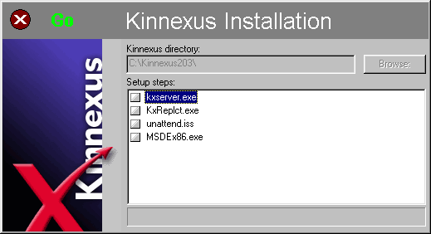
The Kinnexus replication program uses Microsoft MSDE (Microsoft SQL Server Desktop Engine) or Microsoft SQL Server 2005 Express Edition, KxServer and KxReplct. To use the Kinnexus replication program you must install all of these programs from Kinnexus.com and/or Microsoft.com, as appropriate.

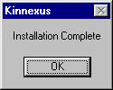
Important Notes:

If you install Microsoft SQL Server Desktop Engine, there is a long period during the installation when nothing appears to be happening. Do not abort or cancel the installation. The installation is not complete until an “Installation Complete” dialog box appears on your screen. If it never appears, check to see that the “Installation Complete” message is not hidden behind other windows. If it is not, check to see that your operation system is earlier than Microsoft XP Service Pack 2, which is incompatible with MSDE. If you have Microsoft XP Service Pack 2 or later, you must install Microsoft SQL Server 2005 Express Edition (or later) instead of MSDE.

If you install Microsoft SQL Server 2005 Express Edition, accept the default values in the installation wizard, with these exceptions. You must do the following:

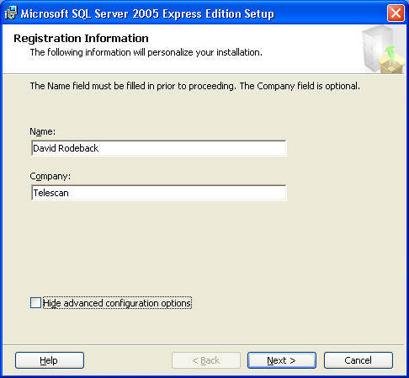
- In the “Registration Information” page of the setup wizard, a checkbox captioned “Hide advanced configuration options” is checked by default. You must uncheck it before proceeding.

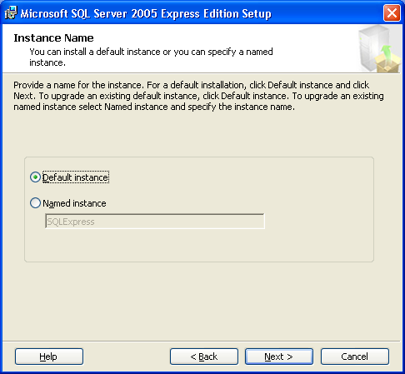
- In the “Instance Name” page of the setup wizard, “Named Instance is selected by default. You must select “Default Instance” instead.

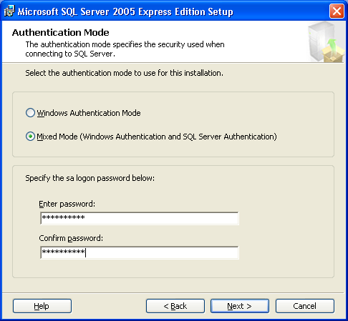
- Under “Authorization Mode” you must select “Mixed Mode” and enter password “kx25secure” (twice).

When SQL Server Express Edition setup is complete, one more step remains: to enable SQL Server to communicate using the TCP/IP protocol.

- In your program menu go to “SQL Server Configuration Manager” (typically Start | All Programs | Microsoft SQL Server 2005 | Configuration Tools).
- Expand SQL Server Network Configuration in the tree and select “Protocols for MSSQLSERVER.”
- One of the listed protocols should be TCP/IP; it will most likely be disabled. Right-click on it and choose “Enable” from the menu which appears.
- When you have made this change, you will be warned that it will not apply until the service is stopped and restarted. You can do this from Control Panel | Administrative Tools | Services or simply restart the computer.

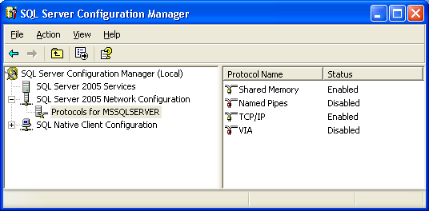

Installing Kinnexus Replication from the Kinnexus Web Site

- Open the Kinnexus Web Site using your Internet browser. The address (URL) of the Kinnexus Web Site is www.kinnexus.com.
- Click on the Kinnexus 3.0 Downloads link.
- Under the heading “Replication” follow the instructions to select and install the appropriate Microsoft database engine for your operating system. This may involve installing the engine and required prerequisites from Microsoft.com.

Figure 2. Login Dialog Box
- Generally, you should choose “Open” or “Run” instead of “Save” when asked what to do with a setup file you’ve selected from the Web.
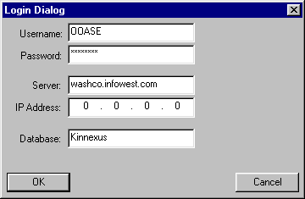
- When the database engine installation is complete, click on Kinnexus Replication Setup. The File Download dialog box will appear. Click on the Open Button. This will download the Kinnexus replication program to your computer.
- When the download is complete, the Kinnexus Installation dialog box will appear (see Figure 1). Click on the Go button.
- When the installation is complete the Kinnexus Installation Complete message will appear. Click OK and restart your computer.
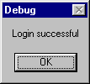
After restarting, you will have a new Icon on your Desktop that says Kinnexus Replication. You will also notice that an icon for the MSDE and KxServer will appear as running services, usually at the bottom right of your screen. The MSDE icon should have a small green arrow on it, indicating that it is running.

Configuring your Replication Program

- Click on the Kinnexus Replication Icon on you desktop.
- When the Login Dialog box appears, enter the appropriate information in the blanks. This is the same information that you used to log into Kinnexus for the first time. If you have forgotten this information, you can find it by bringing up the regular Kinnexus login screen, clicking on the Systems button and then clicking on the Properties button.
- Click OK.
- When the Login Successful message appears, click OK.
- When the Kinnexus Replication Client dialog box (see Figure 3) appears, fill in the blanks with the following information:
  - Destination local database server: Type in the name of your computer. If you aren’t sure what your computer’s name is, you can find it by going to your Network Neighborhood Properties (right click the Network Neighborhood icon on your desktop and click on properties) and selecting the Identification Tag.

Figure 3. Kinnexus Replication Client Dialog Box

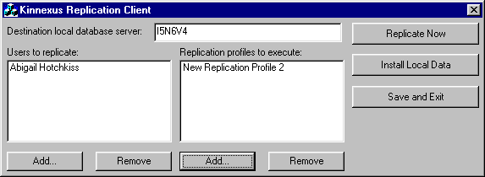
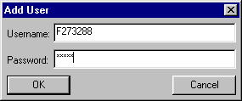
  - Users to replicate: Use this feature only if other users accessing this computer through a network will use the replicated database (this computer is an office server). Click on the Add button. When the Add User dialog appears (see Figure 4), enter the username and password of the user that will access the replicated database on the computer on which you are configuring the replication program. Click OK. You can repeat this process to add additional new users.

Figure 4. Add User Dialog Box
  - Replication profiles to execute: Click on the Add button and select a replication profile that describes the data that you would like to replicate on your computer. You can select more than one profile by repeating this step. If you would like to add a profile that is not on the list, you should contact your system administrator.
  - Your replication system is now configured. You can either leave the replication program by clicking on the Save and Exit button or download the replication data by using the following instructions.
  - To download the replication data from the server at this time click on the Replicate Now button. Your bandwidth and the size of the database you are replicating will determine how long the replication will take. It could be as long as a few hours for the initial replication. It will take your computer about 5 to 10 minutes to determine exactly what will be brought down from the server to your computer. You won’t see any other indication on the screen except an hour glass when you put the mouse pointer over the dialog box. Once the data is actually being transferred, you will see a replication progress bar that will visually indicate where you are in your download process.
  - If you have a CD with replicated data furnished by your administrator, you can import the data into your local database by clicking on the Install Local Data button.

There are a few items that you should know about the Kinnexus replication process. First, the Kinnexus replication program compares the replicated data on your computer with the server data that is in your selected replication profiles on the server. If you are interrupted during your replication and you restart it, you will only bring down the data that wasn’t brought down in earlier replication sessions. This means that if you lose a connection during a long replication download, you can continue to restart the process until you get all the data. In other words, you can effectively break up a long replication download into a number of smaller downloads.

Second, you can bring down more than one replication profile and the Kinnexus Replication program is smart enough to bring down overlapping data only once, thus saving a considerable amount of time.

Third, the Kinnexus Replication program will automatically delete any data from your local database that does not belong in your current replication profiles. If you change your profiles, or if data no longer belongs in a profile because of its date sensitivity, Kinnexus will automatically delete the data from your local database.

Updating Your Replicated Database
You can update your replicated database at any time by logging into the replication utility. To log in, click on the Kinnexus Replication icon on your desktop and complete the log in data as described in the Configuring Your Replication Program section above. Click Okay and click Okay when the Login Successful message appears. Then click the Replicate Now button. This may take a few minutes, depending on your bandwidth.

Configuring your Client Software for Replication
The replicated data is stored in a different database than your normal Kinnexus data. You can search the replicated data exactly the same way you search data in the normal Kinnexus database. However, you must configure your Kinnexus program to see the replicated database. To do this,

- Open Kinnexus to the log in dialog box. Click the down arrow at the right side of System window and click on New System.
- Click on the Yellow Arrow that points to the Right. Complete the information in the dialog box as follows:

Description: Replicated Database
Server Name: Type in the name of your computer. If you aren’t sure what your computer’s name is, you can find it by going to your Network Neighborhood Properties (right click the Network Neighborhood icon on your desktop and click on properties) and selecting the Identification Tag. .
Database Name: Type in the Server Name of the server where the online data resides and the Database Name that you are replicating. Omit any periods, spaces or other symbols in this name. This should be typed altogether as one word. For example, if your online system server name were washco.infowest.com and its database name were Kinnexus, the database name for the replicated data would be washcoinfowestcomkinnexus.

- If you are using Kinnexus version 2.0.3 or later, click the yellow arrow that points to the right, and then click the Go button. If you are using Kinnexus version 2.0.2 or earlier, click the yellow arrow that points to the right as it appears for three consecutive times, then click the Go button.
- To access this database in the future, just select it as your database on the login screen (in the system window) and then click the Go button.

Searching Your Replicated Data
Once you have logged into the replicated database, you can search the data the same way you do in your normal Kinnexus database. However, there are some differences. First, you cannot do data entry with this program. Second, the data is only as current as the data that you have replicated. Finally, you can only access the data that was included in the replication profile(s) that you selected. This may cause you to see different results in your replication searches than you see in your online searches.

