

Quick Start
An Introduction to
Kinnexus 2.0

Warren County Association of Realtors

Table of Contents

Table of Contents 2
Installation and Logon 3
Initial Logon 3
Normal Logon 4
Software Updates 5
Searching 5
Searching Using a Map 7
Portfolios 8
Listviews 9
Deleting Columns 9
Moving Columns 9
Adding Columns 10
Adjusting the Width of Columns 10
Grouping 10
Highlighting and Filtering Search Results 12
Listview Properties 12
Saving Listviews 13
Changing Listviews 14
Viewing Graphs/Trends 14
Viewing Detail Forms 14
Printing 14
Print Preview Mode 14
Printing 15
Email 16
Entering or Modifying Data 16
Entering an New Listing 17
Saving Your Listing 18
Activating Your Listing 18
Changing the Status of Your Listing 18
Modifying a Listing 18
Entering a New Contact 18
Doing a CMA 19
Creating a CMA Listing 19
Doing a CMA Search 19
Viewing and Printing a CMA Presentation 20

Installation and Logon

Before you can install Kinnexus, you must have Internet Explorer 5.5 or later installed on your computer. If you don’t have Internet Explorer 5.5 installed on your computer, you can download it at no cost from http://www.microsoft.com/windows/ie/default.htm. If you have a Kinnexus 2.0 CD, install the Kinnexus client using the following instructions. If you don’t have a Kinnexus 2.0 CD, you can download the Kinnexus client software from www.kinnexus.com.

- Insert the Kinnexus CD in your computer CD drive and wait for the Kinnexus Installation screen to appear on your computer. If you are installing from your network, contact your system administrator for instructions.

- When the installation screen appears, click on Kinnexus and follow the instructions on the screens that follow.

- When the installation is complete, close the Kinnexus installation screen by clicking on the x at the top right corner of the screen.

To install from the Internet, use the following procedure:

- Open www.kinnexus.com and click on Technical Information. Under Kinnexus 2.0 click on Download Kinnexus.

- When the File Download dialog box appears, select Run This Program from Its Current Location and click OK. When the Security Warning dialog box appears, click Yes.

- When the Kinnexus Unpacking dialog box appears, click the Go button. This process may take up to 20 minutes, depending on your Internet connection speed.

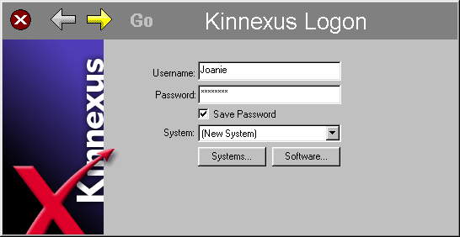
- To install mapping, go to Technical Information, select Maps for Kinnexus 2.0, select FlintMap.exe and follow the same download procedure in steps 2 & 3.

Initial Logon
To logon to Kinnexus, you must be connected to the Internet. The first time you logon to Kinnexus you should complete the following steps. If you have logged on previously, you should proceed to the Normal Logon section.
Figure 1. Kinnexus Logon Screen

- When the installation is complete you can logon to Kinnexus. The first time you logon you must enter some information about the location and name of the Kinnexus database (subsequent logons will only require one click). Complete the information as required and as shown in the following screens.

- Double click on the Kinnexus icon on your desktop. When the Kinnexus Logon screen appears (see Figure 1), type in your Username and Password (get your username and password by calling Telescan at 801 492 0001). If you are the only person that uses your computer, click the Save Password box. Then click on the yellow arrow at the top of the screen.

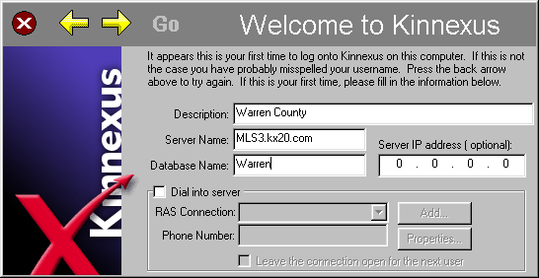
- Fill in the Description, Server Name and Database Name in the appropriate boxes on the Welcome to Kinnexus screen (see Figure 2). The spelling for the Server Name and Database Name should be exact. The Server Name is mls.wcarmls.com and the Database name is Kinnexus. Then click on the right yellow arrow on the top of the screen.
Figure 2. Welcome to Kinnexus Screen

- When the Download Profiles screen appears, don’t change anything; just click the right yellow arrow. When the Online Database screen appears, once again, don’t change anything, but click on the right yellow arrow.

- When the Cold Starting screen appears, click on the green GO button. Kinnexus will now download the proper system configuration to your computer. This may take anywhere from a few seconds to a couple of minutes, depending on the speed of your Internet connection. When it finishes the download, the Kinnexus home page will appear.

Normal Logon
- Double click the Kinnexus icon on your desktop. When the Kinnexus Logon screen appears, it should already have your username and password typed in. If not, type in your username and password. If you are logging as a new user for the first time, go back and follow the Initial Logon procedure.

- The Progress screen will appear while the latest changes to your configuration are downloaded from the Kinnexus server, and then the Kinnexus home page will appear.

- If you are logging in as a different user that has not logged on this computer before, just type your new username and password and click the yellow right arrow (or press the enter key). Continue to click the right arrows until the Cold Starting dialog box appears. Click on the Go icon and Kinnexus will download your unique configuration to your computer. Subsequent logons will only require a normal logon.

Software Updates
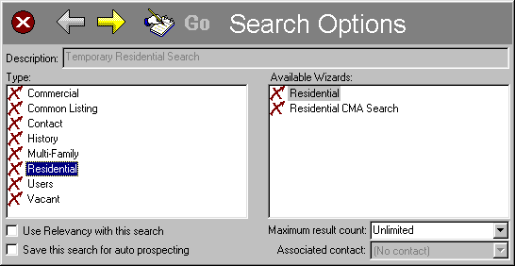
Occasionally, there will be Kinnexus software updates to keep the system current with new features and bug fixes. If there is a new update, after clicking Go on the Kinnexus Logon screen there will be a message that appears that will tell you that there has been a new software update. Click OK and Kinnexus will close and reopen automatically with the new software version.

Searching

There are two ways to start a search for data in the Kinnexus system. The easiest and quickest way to do a search is to click on a Quick Search icon at the upper left of the screen. If you want to save your search criteria and results, you should start your search by clicking on the New Search icon just below the Quick Search icon. If you are planning to save your search, start with step one. If you don’t plan to save your search, skip to step 4.

- Click on the New Search icon in the Favorites navigation tray on the left side of the screen. A Search Options dialog box will appear (see Figure 3). Click on the subject that you want to search in the Type window. Click in the box on the bottom left of the dialog box titled, ”Save this search for auto prospecting”. Now type a title for your saved search in the Description box at the top of the dialog box.
Figure 3. Search Options Dialog Box

- Kinnexus will save this search and place it in your search portfolio. To see the results of this saved search in the future, click on the Search Portfolio icon in the Favorites navigation tray, and then double click on the line that has the title of your saved search.

- Click on the right yellow arrow at the top of the Search Options dialog box. Skip to step 5.

- Click on a Quick Search icon at the top of the Favorites navigation tray (left side of your screen).
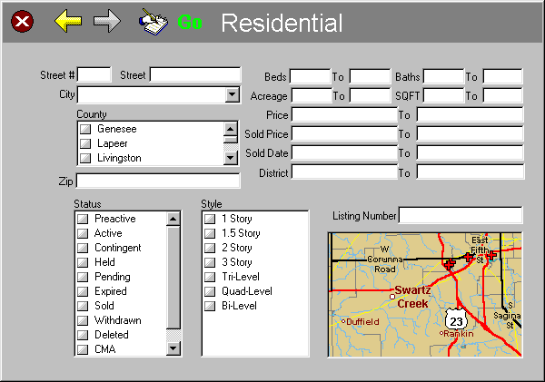
- The appropriate search wizard will appear (see Figure 4). The search wizard has a number of the most commonly searched fields from the selected database. To define a search, enter the criteria of your search in the appropriate field(s). For instructions on formats to use for date fields, refer to Table 1, or for help when searching a text field refer to Table 2. If the right yellow arrow is visible, this means you can click it to see another page of the search wizard. To start the search either click on the Go button at the top of the wizard, or press the enter key.

- If you can’t find the field(s) on the search wizard that you want to use to define your search, you can search on any field in the database by clicking on the handwriting icon at the top of the search wizard. This will open a search form that contains all fields in the database. Enter your search criteria in the beige highlighted areas to the right of the selected field. When you are ready to search, click on the Go button at the bottom of the screen.
Figure 4. Search Wizard

Table 1. Formats for Searching Date Fields
To Get This | Enter This | Additional Information
December 1-15, 2000 | 12/1/00 – 12/15/00
December 1-15, 2000 | Dec 1, 2000 to Dec 15, 2000
December 1-15, 2000 | 1 Dec 00 – 15 Dec 00
December 1-15, 2000 | 12/1 – 12/15 | If you don’t specify a year, Kinnexus assumes the current year.
All dates prior to December 15, 2000 | <12/15/00
All dates after December 15, 2000 | >12/15/00
Any date in the last three days | Current -3d | There is a space between current and the negative sign.  d = Days  w = Weeks  m = months  y = years
Any date in the last two weeks | Current -2w | You can also use a plus (+) sign to check dates in the future. This is helpful to search for suspense dates.
Any date prior to the last 30 days | Priorto30 | This function is useful to find records that have reached an overdue status. Any number of days can be entered in the place of 30.
Using a Wild Card (*) in a Search
When searching on a text field, Kinnexus will search for exactly what is written. This is not always useful, especially when searching a field that has more than one word in it. For example, if you are searching for all records that have Broadway in the street field, you can type Broadway in the street field. This will not produce many results, because Kinnexus is looking for any record that has only Broadway in the street field, and there are just a few. Nearly every record that has Broadway in the street field also has other words around Broadway, such as, “Broadway Ave”. To search a text field to find all records that have Broadway in the street field, enter *broadway* as the criteria. The * symbol tells Kinnexus to find the records that have broadway in them, but there can be other words before and after the word, broadway.
Table 2. Formats for Searching Text Fields
To Get This | Enter This | Additional Information
All records with the word broadway in a particular text field | *broadway* | The * symbol is called a wild card and replaces all text where it is used.
All records that have either a doorman or elevator in a particular text field | *doorman*,*elevator* | A comma used in a text field separates search parameters.

Searching Using a Map
Kinnexus has a fully integrated map feature. This means you can define where you want to search on a map as part of your search criteria. To search using a map use the following procedure.
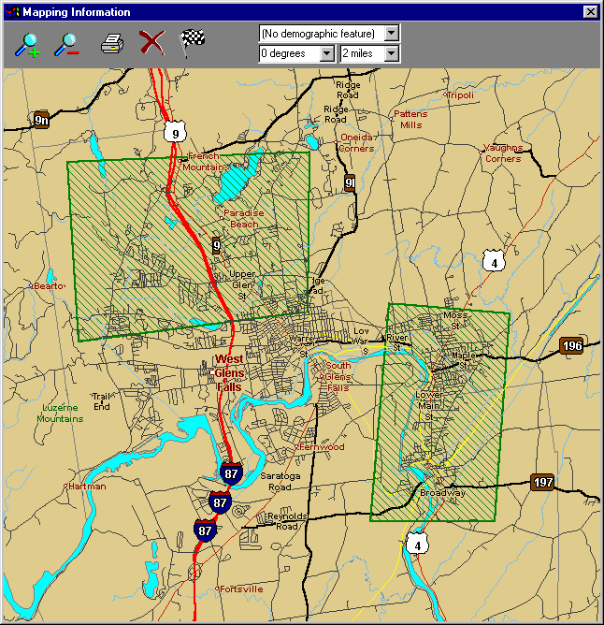
- Click on the map on the search wizard (see Figure 4). The Mapping Information dialog box will appear (Figure 5).

- You can adjust the scale of the map using the zoom buttons at the top left of the map box, or you can zoom closer by clicking and dragging a rectangle on the map.

- You can position the map by holding down the control key and dragging the map. To measure distance on the map, hold down the Shift key while dragging the mouse from one point to another on the map.
Figure 5. Mapping Information dialog.

- To view demographic data on the map, click on the drop down box at the top right of the map and choose the demographic feature you would like to view.

- To define a search area on the map, hold down the Alt key and click the four corners of a rectangle that defines your search area. You may repeat this process to define additional search areas. Your defined search area is marked with a green crosshatch area. Click on the finish flag to save the defined area as part of your search criteria.

Portfolios

The Portfolio feature in Kinnexus is used to provide quick predesigned reports that are automatically customized for you when you log into Kinnexus. How to create a Portfolio report using the Portfolio Manager is explained in the Advanced Users Manual. A number of Portfolio reports have already been created for your convenient use. You can open these predesigned reports by clicking on a Portfolio icon in one of the navigation trays – usually in the Portfolio, Reports, or Favorites tray. Some examples of the portfolios could include your active listings, your sold listings, your saved searches or all properties sold by you.

Listviews

Kinnexus shows the results of a search in a Listview, that is, a tabular list of results with one line per search result record. The Listview shows the search result data in selected columns, with the heading of each column on the gray bar just above the search results. You can delete columns, add new columns, and move columns to new positions. As you read the following paragraphs, refer to Figure 6 for help in locating the items referred to in the directions.
Listview Search Results
Field Chooser
Figure 6. Listview Screen Layout
Navigation Tray
Column Heading
Next Step Bar
Grouping Heading
Highlighter Icon
Current View Resource
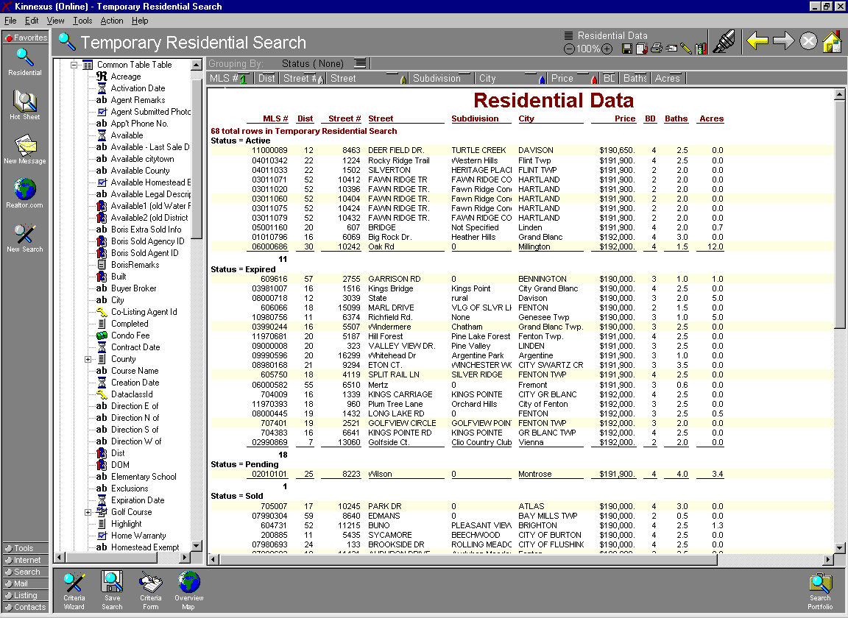

Deleting Columns
To delete a column from a Listview, place the mouse pointer on the Column Heading (gray bar at the top of the search results) and click the mouse on the title of the column you want to delete. While holding the mouse button down, drag the title off the gray bar, then release the mouse button. The column will be deleted.

Moving Columns
To move a column to a new position, click the mouse button on the column title (on the gray bar) that you want to move and drag it to a new position on the gray bar. A red vertical line between column titles will designate the new position. To place the column in its new position, release the mouse button.

Adding Columns
Before you can add a column to the Listview, you must display the Field Chooser on your screen. The Field Chooser is normally viewed on the screen, but can be removed. The Field Chooser is a window that looks like the Explorer Bar in the Microsoft Windows Explorer, and is usually on the left side of the screen next to the Navigation Trays. To view the Field Chooser, click on the View Menu item at the top of the screen and select Field Chooser if there is no check mark by Field Chooser. To add a new column to the List View, complete the following steps.

- Expand the Field Chooser tree. To do this, click on the plus sign just left of the small hammer icon at the top of the Field Chooser. Then click on the plus sign left of the appropriate table heading.

- Find the field that you would like to add as a column to the Listview. The fields are listed alphabetically, and you can use the scroll bar on the right of the Field Chooser to scroll through the fields.

- Place the mouse pointer on the title of the field you want to add to the Listview, click the mouse button and hold it down while you drag the field to the Column Heading for the Listview. Release the mouse button when you have placed the field where you desire it to be on the Listview.

As you add fields to the Listview, you may have more than you can view on your screen. If this occurs, a yellow arrow will appear at either the left and/or right end of the Column Heading. You can scroll the Column Heading by clicking on a yellow arrow. Note: Titles in the Column Heading do not always line up with the corresponding columns on the Listview, but are always in the same order as the columns on the Listview.

Adjusting the Width of Columns
You can adjust the width of a column in the Listview by clicking on the vertical line that separates the column titles in the Column Heading and dragging the line to the position you would like. The column width will automatically adjust to the proper width to display all of the information in a column if you double click on the vertical line to the right of a column title on the Column Heading.

Grouping
You can arrange the search results on your Listview into groups and subgroups. This can be very helpful when the search results are used for CMA’s, or by street, etc. To arrange your search results into groups, follow these steps:

- Click on the field title on the Column Heading that you would like to use as the basis of your group. While holding the mouse button down, drag the field title to the Grouping Heading, just above the Column Heading and release the mouse button.

- The Listview will now be arranged in groups based on the field title that was placed on the Grouping Heading. If your group is based on a numerical or date field, and you would like to adjust the size of the group, right click on the field title in the Grouping Heading. When the Properties box appears, click on it.

- The Group Settings dialog box will appear. Click on the appropriate spot for the type of field you are using for your grouping.

- If you are grouping by a date, click on the Date Field spot. Click the down arrow at the right of the Group By box and then click on the size of the group that you want to display. Click the OK button.

- If you are grouping by a number, click on the Numeric Field spot. Type in the size of the group that you would like to view on your Listview (see Figure 7). Click the OK Button.

- To make subgroups, repeat the process in steps 1 through 5 with an additional field. You can make as many levels of grouping as desired.
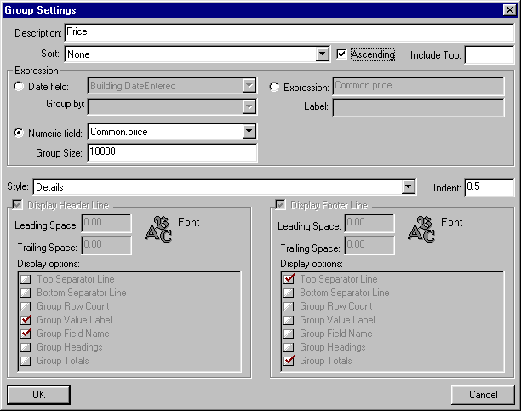
Figure 7. Group Settings Dialog Box for Numerical Groupings

Highlighting and Filtering Search Results
You can select and highlight any number of your search result records (rows) in up to four different highlights. You can then filter your list of results using the highlighted fields as the basis for the filter. You can also filter the results based on the highlights when you print or email your Listview. To highlight rows in the Listview, use the following steps:
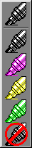
- While holding down the Ctrl key on your keyboard, click on the search result rows that you want to highlight.

- Click on the Highlighter Icon (see Figure 6) at the top of your screen. Then click on the highlight that you would like to use.

- Repeat this process to highlight additional items with a different highlight.

- To remove a highlight, repeat the highlighting process, but select the black highlight color.

To filter the items that you have highlighted use the following steps:

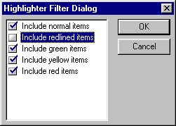
- Click on the Set Highlighter Filter icon, just left of the Highlighter Icon.

- When the Highlighter Filter Dialog appears (see Figure 8), remove the check marks in front of the filter selections that you do not want to be displayed on the Listview by clicking on the check box. Click the OK Button.
Figure 8. Highlighter Filter Dialog Box

- To remove the filter, repeat the process except click to put the check mark next to the highlighted items that you want to appear on the Listview.

Listview Properties
You can change the properties of your Listview, such as font size, color and style, grid line markings and row shading, to suit your personal needs. To set these properties, use the following steps.

- Place the mouse pointer anywhere on the Listview Search Results.

- Right click the mouse and then click on Listview Properties. The Listview Properties Dialog (see Figure 8) will appear. From the Listview Properties Dialog you can change the properties of the Listview

- To change fonts, click either on Row Font or Totals Font. The Font Format Dialog will appear (see Figure 10). From this dialog box you can choose the typeface, font size, font effects, and lettering and background colors. When you have completed your selections, click the OK Button.
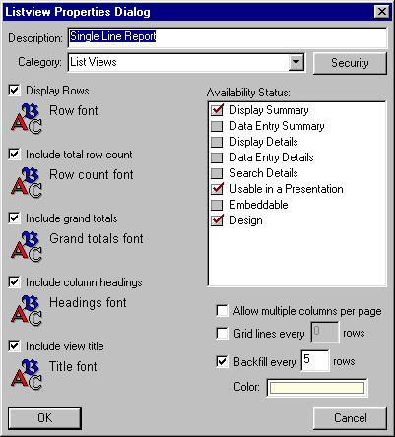
- To place lines at selected row intervals in the Listview, click on the Gridline Row Spacing check box on the Listview Properties Dialog box (see Figure 9). Then type in the interval at which you would like the lines to appear.

- To place an alternating background behind the rows in the Listview, click on the Alternating Backfill Color check box on the Listview Properties Dialog box. You can select the color of the background by clicking on the colored box to the right of the Alternating Backfill Color check box title, and then double clicking on your choice of background color.
Figure 9. Listview Properties Dialog
- When you have completed you selections for the Listview Properties, click the OK Button on the Listview Properties Dialog box.

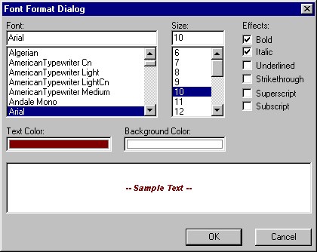
Saving Listviews
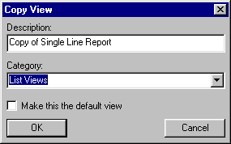
When you change the configuration of your Listview, either by changing columns and/or groupings, or by using the Listview Properties Dialog, you may be able to save your changes, depending on whether the system administrator has given you the right to do so. If you don’t have the right to save your changes, when you try to save them the save icon at the top of the screen will be grayed out. If you have the right to save your Listview changes as a new Listview, the save as icon at the top of the screen will not be grayed out and you can click on it. When you click on the Save As icon the Copy View Dialog Box will appear (see Figure 11). You can choose to save your new Listview configuration for future use by typing in a name for your Listview in the description box, choosing a view category where the new Listview will be saved and then clicking the OK Button. You can also choose to make this Listview the default Listview; that is, you can choose to have this new Listview appear any time you use a Listview.
Figure 10. Font Format Dialog
Figure 11. Copy View Dialog Box

Changing Listviews
You can save a number of Listview configurations to be viewed later. In addition, there are some default Listview configurations that can be used to display your search results. To change the Listview configuration used to display your search results, click on the Current View Resource label at the top of the screen (see Figure 6). Move the mouse pointer to the Listview folder from the drop down list, and then click on the desired Listview Configuration.

Viewing Graphs/Trends
You can view a trend analysis of data in a Listview in a bar graph format. To select the Graph view, click on the Current View Resource label at the top of the screen (see Figure 6). Move the mouse pointer to any view that has a graph icon to the left of its title.

Viewing Detail Forms
To view the details of a specific search result, double click on any row in the Listview. The details of the selected record are shown on the screen. You can choose how the details of the record are shown by clicking on the Current View Resource label at the top of the screen (see Figure 6). Move the mouse pointer to the Report folder and then click on the desired report configuration.

Printing

You can print any view of data that appears on the screen.

Print Preview Mode
To see exactly how the data will appear when printed, you can select a print preview mode. To select the print preview mode, click on the Current View Mode Button at the top of the screen (see Figure 6). Then click on Print Preview Mode. To select draft mode, click on the Current View Mode Button at the top of the screen, and then click on Draft Mode.

Printing
You can print data by either selecting Print from the File menu at the top left of the screen, or by clicking on the Print icon at the top near the right of the screen. Either of these actions will display the Print dialog box (see Figure 12). Most items in the Print dialog box are standard Windows print options. To configure the items specific to Kinnexus, use the following steps.

- If you are printing a Listview, you can specify which highlighted rows you want to print by selecting the Include Selected Rows option and then checking the appropriate highlight boxes. By checking the Normal box you will print all rows in the Listview that are neither highlighted nor selected with the normal Windows selection, and by checking the Selected box you will print all rows that have been selected with the Windows selection (usually marked with a dark blue background with white writing).

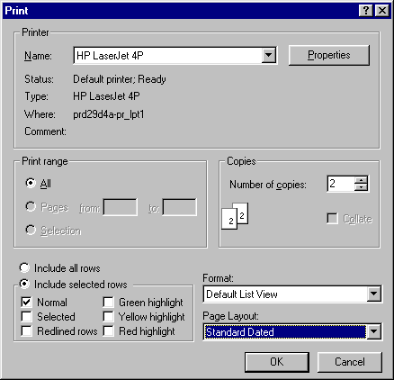
- If you want to print your results in a different format than what you see on your screen, you can select from the available formats by clicking on the down arrow to the right of the Format selection box, and then clicking on the desired print format. If you want to print information in the format shown on your screen, leave the selection as (Current Report).

- You can print using a saved page layout that includes previously designed headers, footers, and page size. The system is set to print the page layout of the current view on the screen, and will do so if the Page Layout option is left to read (Current Layout). If you would like to print in a different layout, you can select one by clicking on the down arrow to the right of the Page Layout selection box and then clicking on the desired layout.
Figure 12. Print Dialog Box

Email

You can email whatever is shown on your screen by using the email function. When you send an email using Kinnexus you can choose to send the current information on your screen as an attachment. The screen will be sent as an HTML attachment that can be opened by the recipient of your email in their Internet browser. To send an email, use the following steps (see Figure 13).

- Click on the Email icon to the right of the print icon at the top of the screen. The Mail Attachment Properties dialog box will appear.

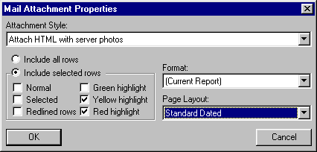
- If you are sending a Listview, you can specify which highlighted rows you want to email by selecting the Include Selected Rows option and then checking the appropriate highlight boxes. By checking the Normal box you will send all rows in the Listview that are neither highlighted nor selected with the normal Windows selection, and by checking the Selected box you will send all rows that have been selected with the Windows selection (usually marked with a dark blue background with white writing).
Figure 13. Mail Attachment Properties Dialog Box

- If you want to email your results in a different format than what you see on your screen, you can select from the available formats by clicking on the down arrow to the right of the Format selection box, and then clicking on the desired format. If you want to send information in the format shown on your screen, leave the selection as (Current Report).

You can email using a saved page layout that includes previously designed headers, footers, and page size. The system is set to email the page layout of the current view on the screen, and will do so if the Page Layout option is left to read (Current Layout). If you would like to email in a different layout, you can select one by clicking on the down arrow to the right of the Page Layout selection box and then clicking on the desired layout.

Entering or Modifying Data

To enter data, such as a new listing or contact, or to modify data, such as an existing listing, the system administrator must first give you the rights to do listing data entry. If you can see Listing Tab on your Navigation Tray, and if you click on the Listing Tab and see a Create Listing icon, then you can enter listing data.

Entering an New Listing
To enter a new listing, use the following steps.

- Open the Listing Tray. This is done by clicking on the Listing Tab on the Navigation Tray (see Figure 6 to locate the Navigation Tray).

- Click on the Create Listing Icon. This will open the Data Entry Options dialog (see Figure 14).
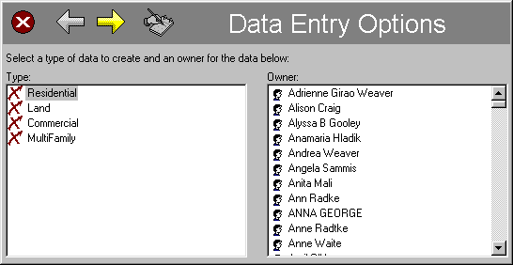
- Select the type of data entry you plan to enter and the Owner of the listing by clicking on them. You may only have one choice, depending on the security you have been given by the system administrator. Then click on the right yellow arrow. This will open the Data Entry Wizard (see Figure 15) for the property type you selected in the Data Entry Options dialog.
Figure 14. Data Entry Options Dialog.

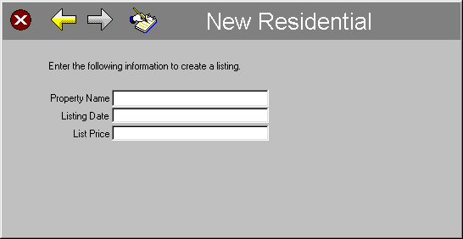
- Complete the information in the boxes provided.

- When this information is completed, click on the Handwriting Icon at the top of the Data Entry Wizard. This will open the data entry form.
Figure 15. Data Entry Wizard.

- To enter data into the data entry form, click the mouse on the first beige-colored box. Enter data into this box and press the tab key to move to the next data entry box. If you are restricted to limited choices with your data, a drop down box will appear. You can either use the mouse to mark your choices or use the arrow keys to select a choice and mark it with the space key.

Data Entry background Color Codes
- Beige – The beige data entry box means that data entry is optional.
- Red – The red data entry box means that this field must be filled out correctly before you can Activate your listing. When it is completed correctly, the color of the field will change to beige.
- Gray – A gray data entry box denotes data that is automatically filled in by the computer. You cannot add or modify data in a gray data entry box.
- Purple – A purple data entry box indicates that the data you have entered in this box may be in error. You should review the data to make sure it is correct.

Saving Your Listing
You can save your new listing at any time by clicking the save button at the top of the screen. It is recommended that you save your listing occasionally during your data entry process.

Activating Your Listing
You can activate your listing by clicking on the Activate Listing icon at the bottom of your screen. The listing can be activated only if there are no red data entry boxes on the data entry form. If the data is acceptable, the Activate Listing Wizard will appear. Enter the information on the wizard and click the Handwriting Icon at the top of the Wizard. The listing will now be active and available for all users on the system to search.

Changing the Status of Your Listing
To change the status of your listing when it is displayed on the screen, click on the appropriate status change icon on the Next Step Bar at the bottom of your screen. Enter the data required in the status change wizard that appears, and then click on the Handwriting icon at the top of the wizard.

Modifying a Listing
To modify an existing listing you must first open the listing in the data entry form. To do this, use the following procedure.

- Open the Listing Tray. To do this, click on the Listing Tab on the Navigation Tray (see Figure 6 to locate the Navigation Tray).

- Click on the My Listings icon on the Navigation Tray. Your Listing Portfolio will open in a Listview. Double click on the listing you want to modify.

- When the listing data entry form opens for the selected listing, you can edit any data entries except the ones with a gray background. When you complete your data modifications, click on the save icon at the top of the screen.

Entering a New Contact
The process of entering a contact in Kinnexus is very similar to entering a new listing. Select the Contact tab in the Navigator Tray and click on the Create Contact Icon. When the Contact Date Entry Wizard opens, fill in the appropriate data. To fill in more data, click on the Handwriting icon at the top of the wizard. Enter data in the appropriate fields. Save the data by clicking on the Save icon at the top of the screen.

Doing a CMA
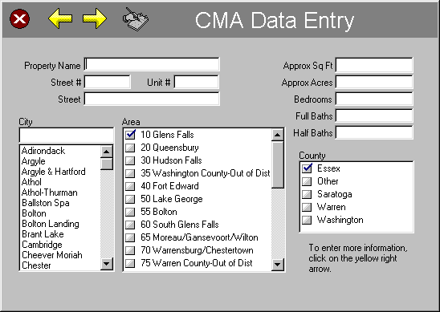
A Comparative Market Analysis (CMA) can be performed using any listing that you own. That is, you can do a CMA on any listing that you have the capability, or rights, to change the listing data. Such listings include the listings in your Listing Portfolio, your Sold Listing Portfolio, your Lost Listing Portfolio, or your CMA Portfolio. In general, you can do a CMA on any listing that is in a portfolio shown in your Listing Tray on the Navigation Tray (see Figure 5).

Creating a CMA Listing
Figure 16. CMA Data Entry Wizard
If you want to do a CMA on a potential listing that you do not have already entered into one of your listing portfolios, you can create a CMA listing, which you can save in your CMA Portfolio. To create a CMA listing,

- Open the Listing Tray on your Navigation Tray (see Figure 5).

- Click on the Create CMA Icon.

- Select the Residential property type (see Figure 16). (The initial setup of Kinnexus only provides CMA capability for the Residential property type. You can create the components for CMAs on additional property types using Kinnexus tools. This generally requires advanced training.)

- Select the person who will “own” this CMA listing. Generally, this will be you.

- Click the right arrow at the top of the wizard, and then enter the information in the next wizard and click on the Handwriting Icon at the top of the wizard.

- Enter any data that is applicable in the Data Entry form. The more detailed you make your data entry; the more accurate the CMA will be in the comparable property selection process.

- Save your data by clicking the save icon at the top of the screen.

Doing a CMA Search
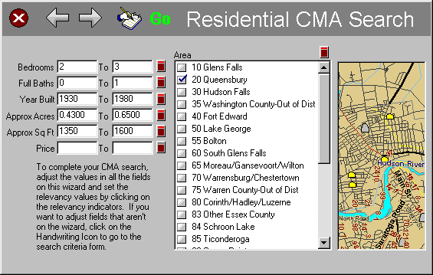
To do a CMA search, you must have a listing open in the data entry mode. When you have a listing open, which will become the CMA subject property, a CMA Search icon will appear on the Next Step Bar at the bottom of your screen (See Figure 5). When doing a CMA search, Kinnexus will compare the data in all the fields in the subject property with potential comparables. Kinnexus will then provide a list of CMA search results grouped by status and sorted by closeness of their match to the subject property.

To perform a CMA search,

- Open your subject property in the data entry mode. This will already be open if you just created a CMA listing. Otherwise, open one of your listing portfolios and double click on the desired subject property.
Figure 17. CMA Search Wizard with Relevancy

- Click on the CMA Search Icon on the Next Step Bar at the bottom of your screen.

- Fill in or edit the information in all the fields on the CMA search wizard (see Figure 17). The Kinnexus CMA search program automatically fills in a range of data in the wizard fields based on the information in your subject property. Some of the ranges automatically inserted by Kinnexus may be outside a sensible range. In such cases, you should correct the information.

- Set the importance of each field for the Kinnexus relevancy (close match) search. Clicking on the relevancy indicator by each field does this. Each time you click on the indicator the importance of this field in the search will increase, until a red line appears at the top of the indicator, which means the search results must fit within the parameters of this field. If you click the indicator again, the importance of this field will reset to zero. Additional clicks will increase the importance.

- You can set/edit additional search fields besides the ones on the wizard by clicking on the handwriting icon at the top of the wizard.

- When you are ready to do the search, click on the GO button.

Viewing and Printing a CMA Presentation
Kinnexus will automatically create a CMA presentation from the comparables found in a CMA search. To view and print a CMA presentation, you must have a list of search results on your screen. Then do the following steps.

- Determine the properties you want to use for comparables. You can look at the details of each property on the list by double clicking on it. To return to the list of properties, click on the back arrow at the top right corner of your screen.

- Select the properties you want to use by holding down the control key and clicking on the desired properties.

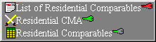
- Highlight the selected properties by clicking on the Highlighter Icon at the top of the screen (see Figure 5) and then clicking on the yellow highlighter. You can repeat steps 2 and 3 until you have highlighted in yellow all of your comparables.
Figure 18. Presentation Selection

- Click on the Current View Resource heading at the top of your screen (see Figure 5). Choose CMA and then click on the CMA presentation you would like to use, usually the Residential CMA presentation. The search light icon to the left of the title denotes a presentation (see Figure 18).
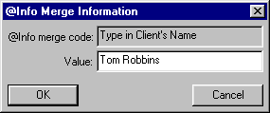
- Enter the title page information requested in the @Info Merge Information dialog box (see Figure 19), and then click OK. Repeat this until all title page information is entered.

- To view the CMA on the screen click on the Current View Mode icon, just to the left of the Current View Resource heading at the top of your page, and select Print Preview Mode. You can zoom and/or scroll the CMA to view all the pages.
Figure 19. @Info Merge Information Dialog

- To print the CMA, click on the print button at the top of your screen.

